Bonsai Health and Basic Care Workshop for Curators, Jonas Dupuich, Part 1

By George Haas  
April 11, 2025

On April 8, 2025, Jonas Dupuich (<https://bonsaitonight.com>) conducted advanced training on Bonsai Health Problems and Basic Care for the bonsai garden’s assistant curators. Assistant curators are the expert volunteers who regularly tend to the care and maintenance of the bonsai trees. A total of 10 assistant curators, plus the bonsai garden’s director and curator attended the training. The training was scheduled from 10:00 a.m. to 2:30 p.m., at the bonsai garden’s workshop.

The workshop began with a field exercise where the students were given clip boards and a handout for identifying bonsai health issues. They were instructed to examine the bonsai trees and to identify whatever they saw as an issue with the health of the trees. After 30 minutes or so, the students were called back into the workshop to discuss what they observed during the field exercise.

Jonas described the following abiotic problems common with bonsai trees:

* Too much/too little water
* Tool much/too little fertilizer
* pH problems
* Too hot/too cold
* Too much/too little light
* Too much wind
* Hail/animal/physical damage
* Poor soil
* Pesticide/fungicide/fertilizer phytotoxicities\*

\**Phytotoxicities refers to toxic effects certain substances have on plants, impacting their growth, development, and overall health.*

Examples of abiotic factors include:

Temperature: Extreme heat or cold can impact plant health.  
Light: Sunlight availability affects photosynthesis.   
Water: Availability and quality are crucial for growth.  
Soil: Nutrients, pH levels, and texture matter.  
Climate: Wind, humidity, and rainfall are key elements.

Common Pests:

Aphids - tiny, sap-sucking insects that can wreak havoc on plants.  
 Scale - small, sap-sucking insects that attach themselves to plants, often resembling tiny bumps or growths on stems, leaves, or branches.  
 Adelgids - small, aphid-like insects that primarily target conifers such as pine, spruce, and hemlock trees.  
 Root aphids - pesky insects that feed on plant roots.  
 Trips - tiny, slender insects that can wreak havoc on plants.  
 Spider mites - sap-sucking pests that can weaken and damage plants. They often leave fine webbing on leaves, which makes them easy to identify.  
 Caterpillars may look harmless, but they can quickly eat their way through leaves, flowers, and even fruits, causing significant damage to plants.  
 Ants - often attracted to sugary residues, food scraps, or even the presence of other pests (like aphids, which produce honeydew).

Common Pathogens:

Powdery mildew - a common fungal disease that affects plants, leaving a white or gray powdery coating on leaves, stems, and flowers  
 Needle cast - a fungal disease that affects conifer trees, causing needles to turn brown or purple and eventually drop off  
 Tip blight - (Phomopsis) a fungal disease that primarily affects conifers, such as junipers, arborvitae, and spruces. It causes the tips of branches to turn yellow, brown, or gray, leading to dieback and reduced plant health  
 Water molds (pythium, phytophthora)  
 Nectria - a genus of fungi that includes species known for causing diseases in trees and shrubs, such as Nectria canker and dieback  
 Fire blight - a destructive bacterial disease caused by Erwinia amylovora. Erwinia amylovora is a Gram-negative bacterium responsible for causing fire blight. It primarily affects plants in the Rosaceae family, such as apples, pears, and ornamental shrubs like hawthorn and cotoneaster  
 Sooty mold - a fungal growth that appears as a black, powdery coating on the surface of leaves, stems, and fruit   
 Leaf spot - a group of plant diseases caused by fungi or bacteria, resulting in small, discolored spots on leaves

Jonas provided the following factors for consideration in basic bonsai care:

Exposure  
 Sun  
 Wind  
 Heat  
 Cold

Watering  
 How much  
 How frequently  
 Watering sick bonsai

Water quality  
 Total solids  
 pH  
 Sodium  
 Chemical injectors

Fertilizing  
 Goals for fertilizing  
 How frequently  
 What kinds  
 Fertigation (fertilization with irrigation)

A discussion was conducted about the role of the assistant curators in making regular observations regarding the health of the bonsai trees, and being capable of taking remedial actions.

Finally, Jonas led the students in examining the bonsai trees in the collection, and pointing out health issues as discussed during the aforementioned lectures.

Part 2, Bonsai Health Problems and Basic Care workshop with Jonas will be scheduled shortly.

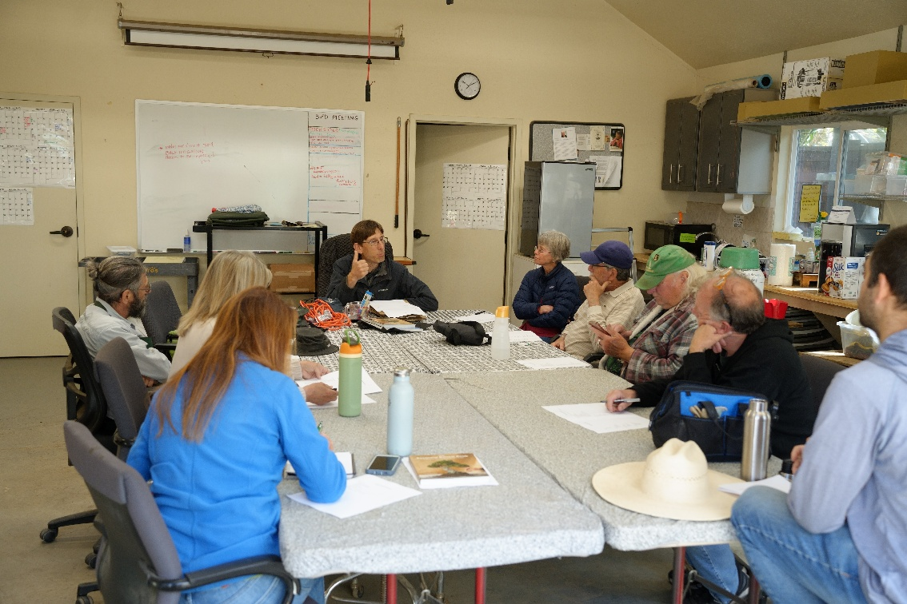

1 Jonas Dupuich led workshop on Basic Health Problems and Basic Bonsai Health

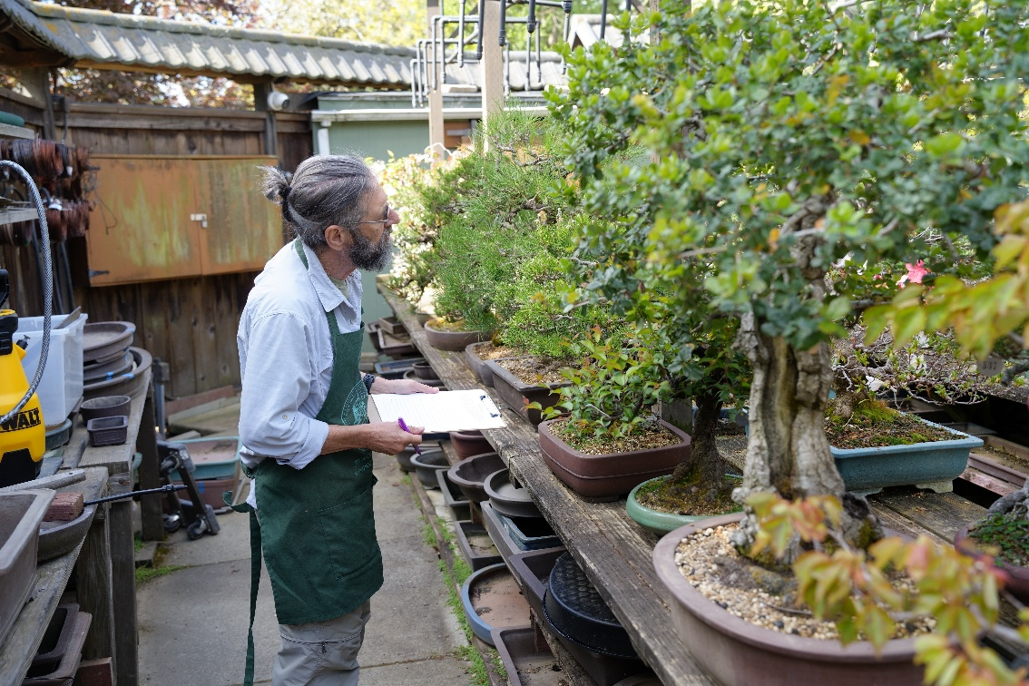

Alexander Dulkins examines bonsai trees for health issues

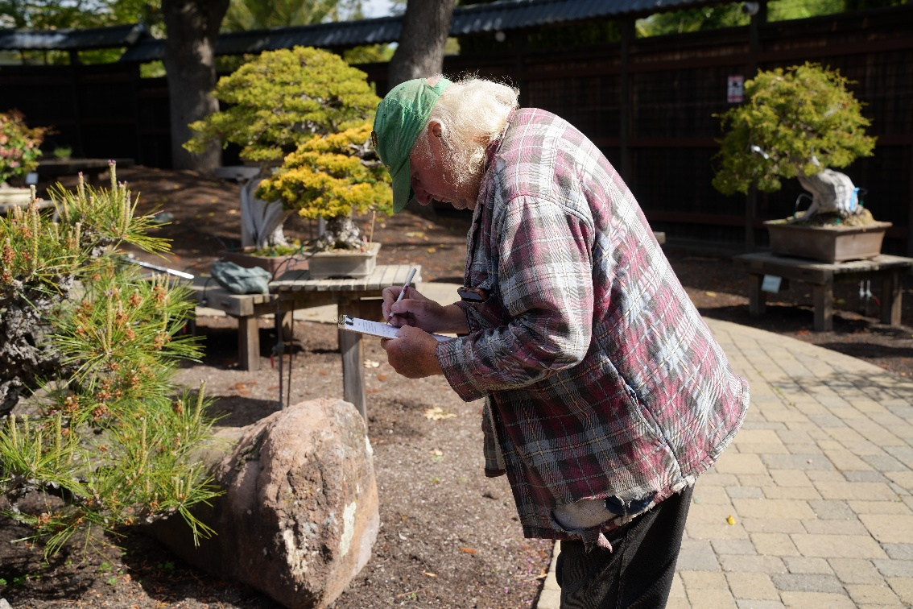

Mike Cullen recording bonsai health issues

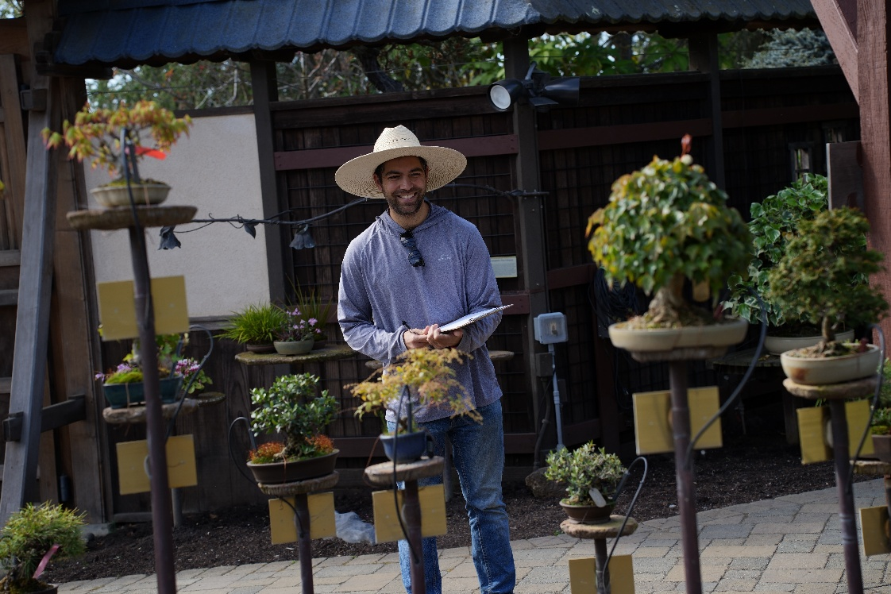

Mike Roberto examining the Shohin bonsai trees

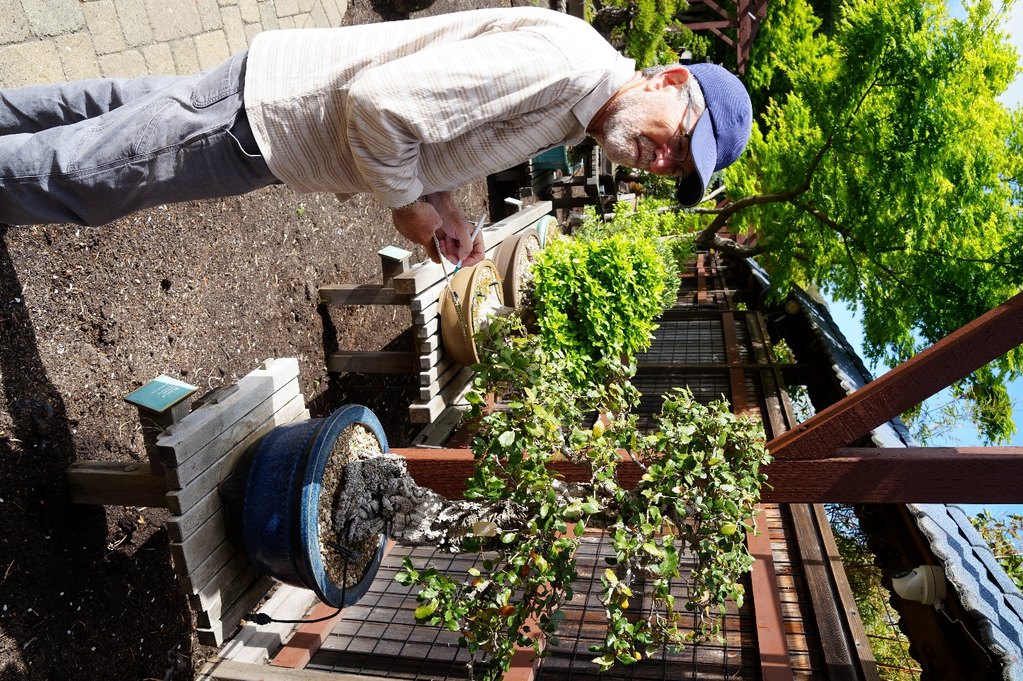

Steve Silberblatt examining Oak bonsai tree

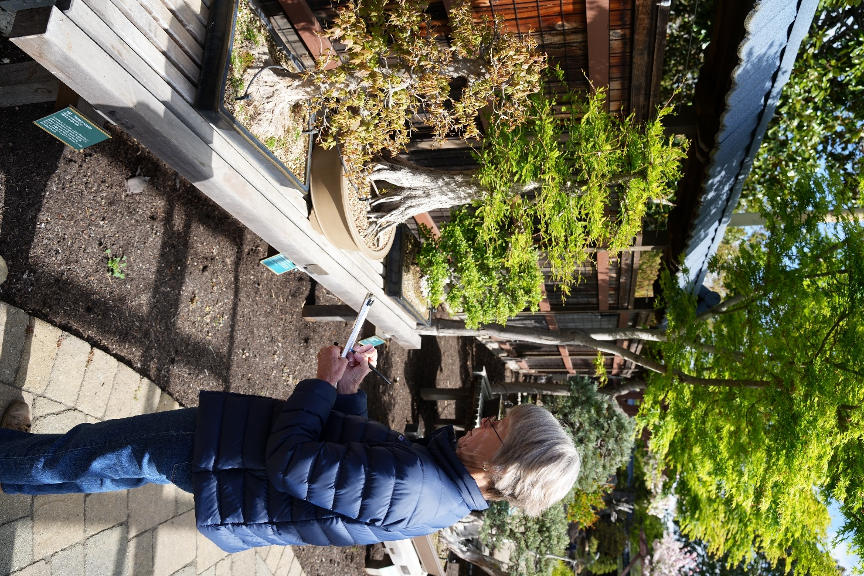

Julie Holcomb notes health issues on Trident Maple bonsai tree

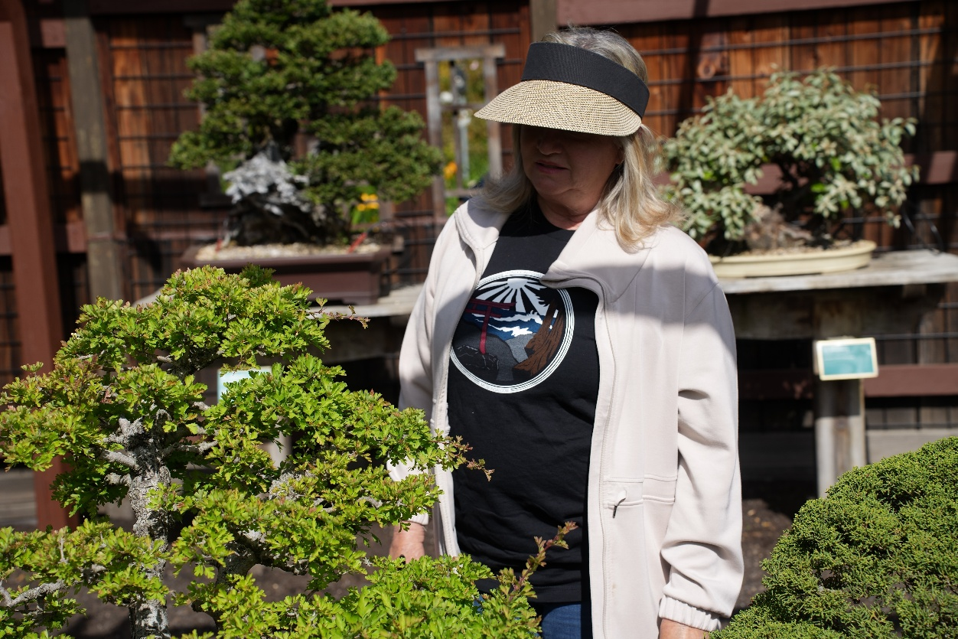

Alise Offerman examining a Cork Bark Oak

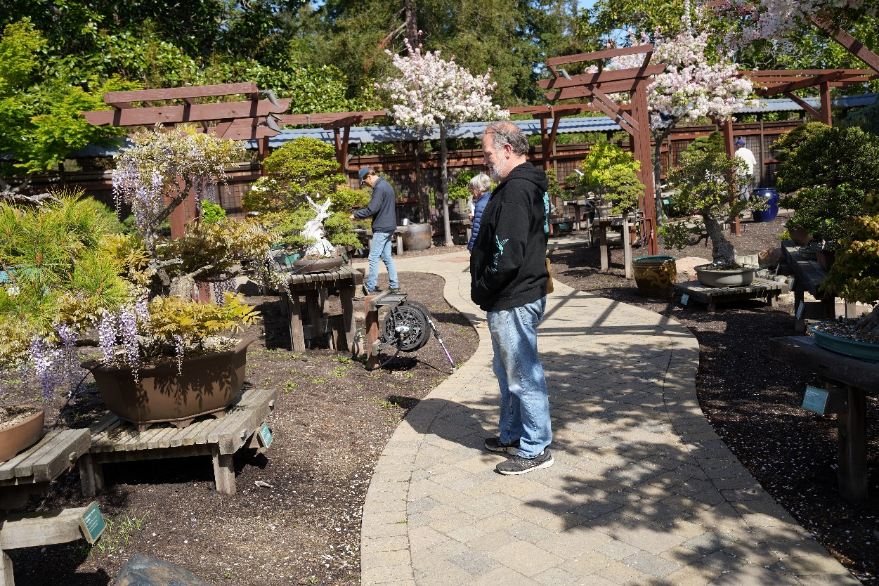

Mark Walker admiring the Japanese Wisteria in bloom

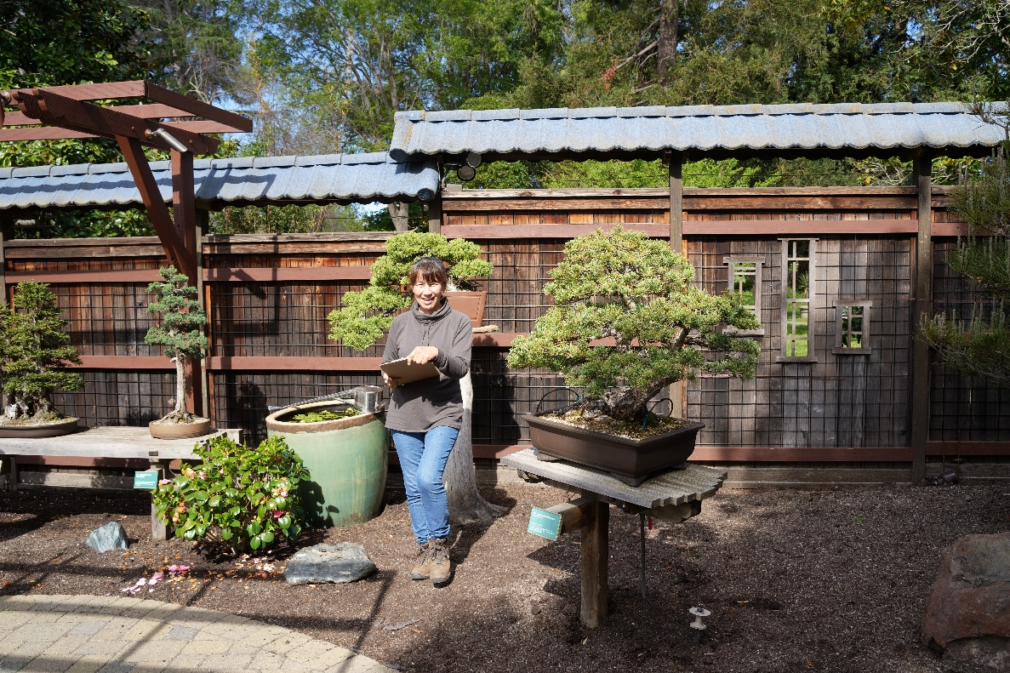

Yuri Aono noting health issues with bonsai trees

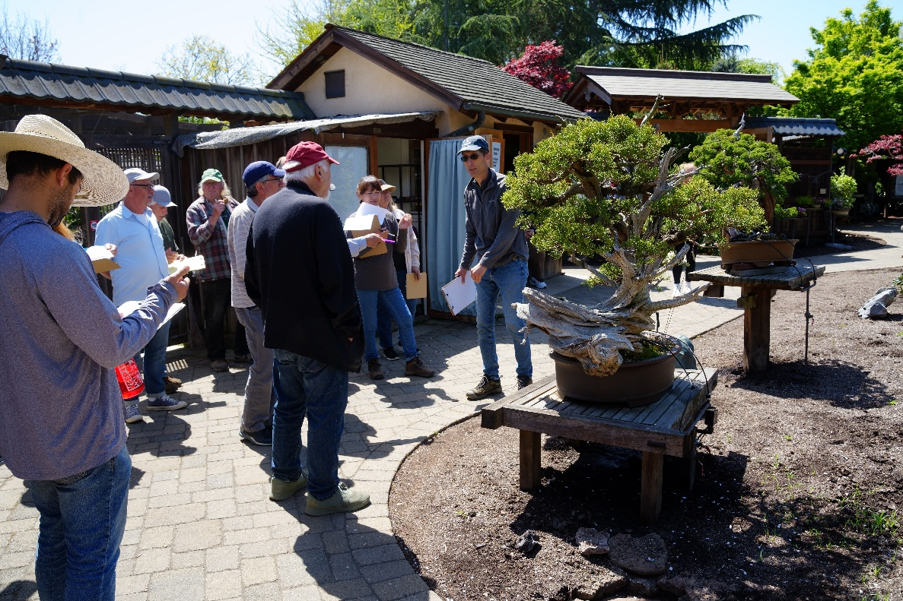

Jonas Dupuich wrapping up the workshop by pointing out health issues

